Sponsorship Application
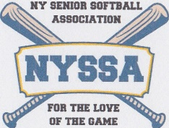

Sponsorship’s Business Name ________________________________________________

Your name________________________________________________________________

Address___________________________________________________________________

Telephone No.______________________________________________________________

Email______________________________________________________________________

Website____________________________________________________________________

Your signature______________________________________________Date_____________

$300 is our requested Sponsor's donation.
Benefits include your name and logo on our website along with a direct link from our website to yours as well as an Honorable Mention at our Awards Luncheon.
Please make your sponsorship check payable to NYSSA.
Payment may be mailed to Jules Balistreri, 41 Symphony Drive, Lake Grove NY 11755.
The New York Senior Softball Association (NYSSA) currently has 8 teams composed of approximately 140 players aged 68 and over.
Our 56 game regular season schedule plus End of Season Tournament and Snowflake Season spans April through the Wednesday before Thanksgiving.
We play doubleheaders on Monday and Wednesday mornings at Cantiague and Wantagh Parks.
We are very thankful to individuals, businesses and organizations that support NYSSA.
Monies are used for equipment, supplies, uniforms, umpire fees, organizational fees, insurance, and field use.
Please direct any questions to info@newyorkseniorsoftball.com

